Synaptonemal & CO analyzer

ANALYZING SYNAPTONEMAL COMPLEXES (SCs) AND CROSSOVERS (COs)

Soriano et al

Version 20.1

1. GETTING STARTED: INSTALLING AND UPDATING THE PLUGIN

**Install ImageJ-Fiji**

Go to <https://imagej.net/Fiji>

Choose your operative system, download FIJI and extract the obtained compressed folder. Double click on ImageJ-win64.exe to start FIJI. Take note of the location of FIJI’s folder.

**Install the Morphology Plugins Package**

Open Fiji and select on the menu bar: Help> Update …> Manage update site. In the pop-up menu select the checkbox “Morphology”, then click on the buttons “close” and “Apply changes”.

Go to <https://imagej.net/ImageJ_Updater> for further documentation.

**Install the** **Synaptonemal & CO analyzer plugin:**

Go to YYY , download the file Synaptonemal_&_CO_analyzer.ijm.

Windows users: close FIJI if open, then paste the file Synaptonemal_&_CO_analyzer.ijm into the FIJI’s plugins folder (Fig.1, top).

Mac OS users: open Fiji, select on the menu bar: Plugins>Install…, on the pop up window, select the path to the file Synaptonemal_&_CO_analyzer.ijm and save into the plugins folder (Fig.1, center).

To run the plugin: Start FIJI and select on the menu bar: Plugins>Synaptonemal & CO analyzer (Fig.1, bottom).

**Figure 1. Top: plugins’ folder. Downloading the *Synaptonemal_&_CO analyzer.ijm* file to this folder is the easiest way to install the plugin. Top: windows OS. Middle: Mac OS. Bottom: once FIJI is restarted the plugin can be executed from the Plugins Menu.**

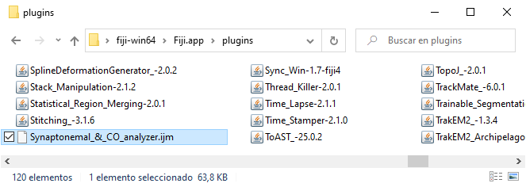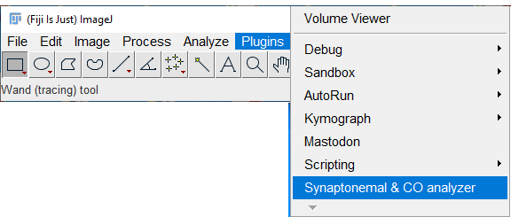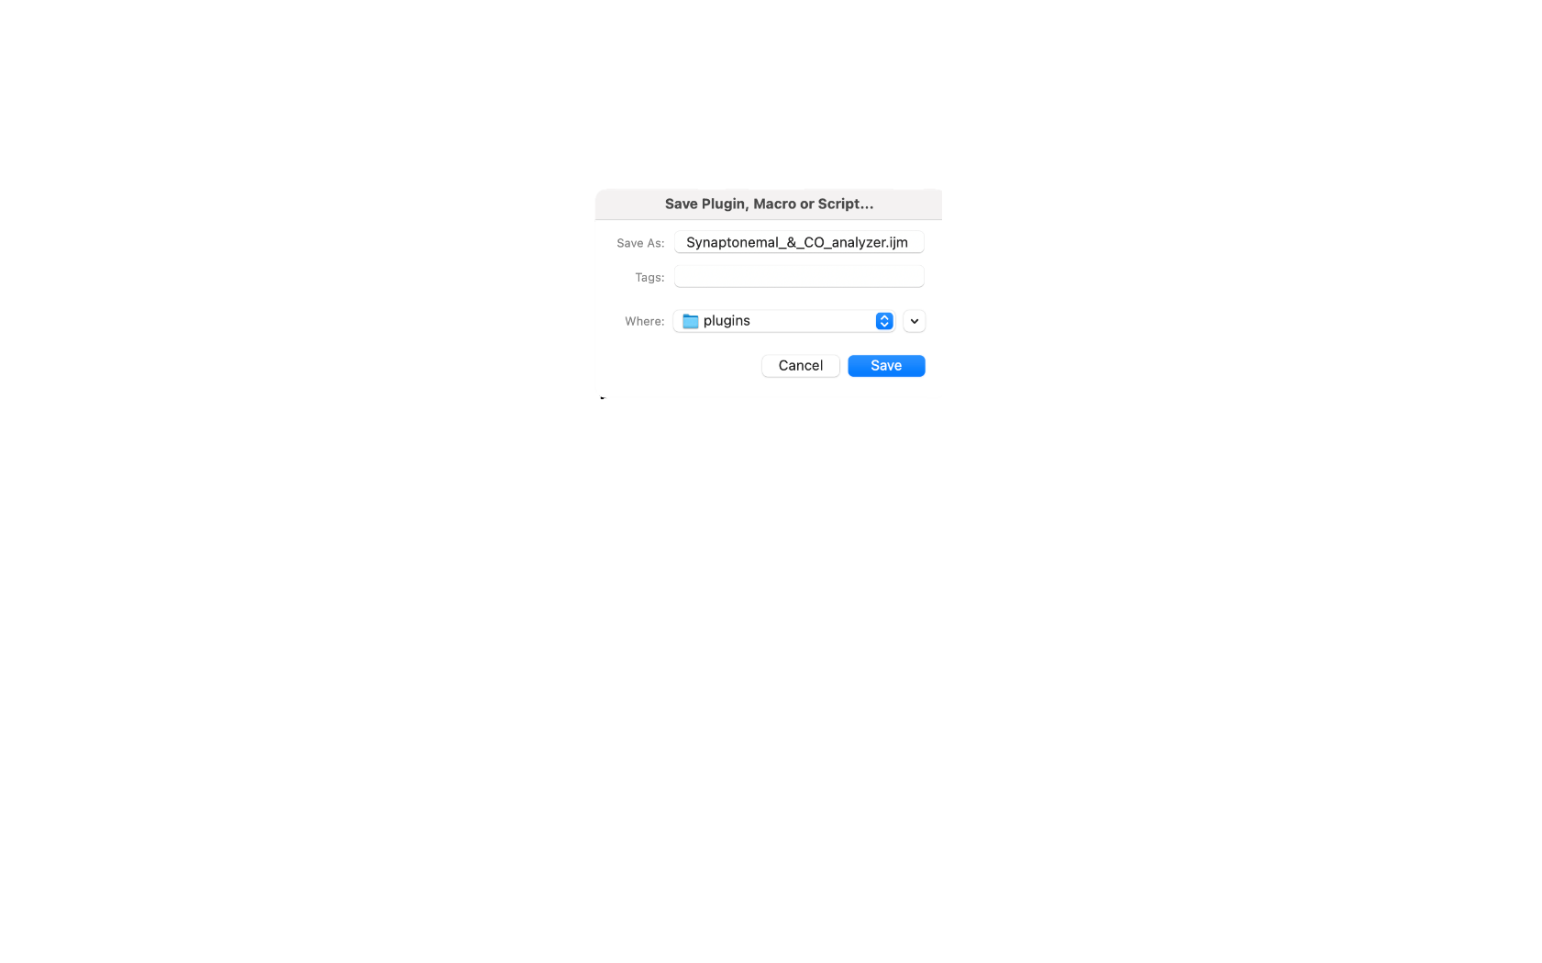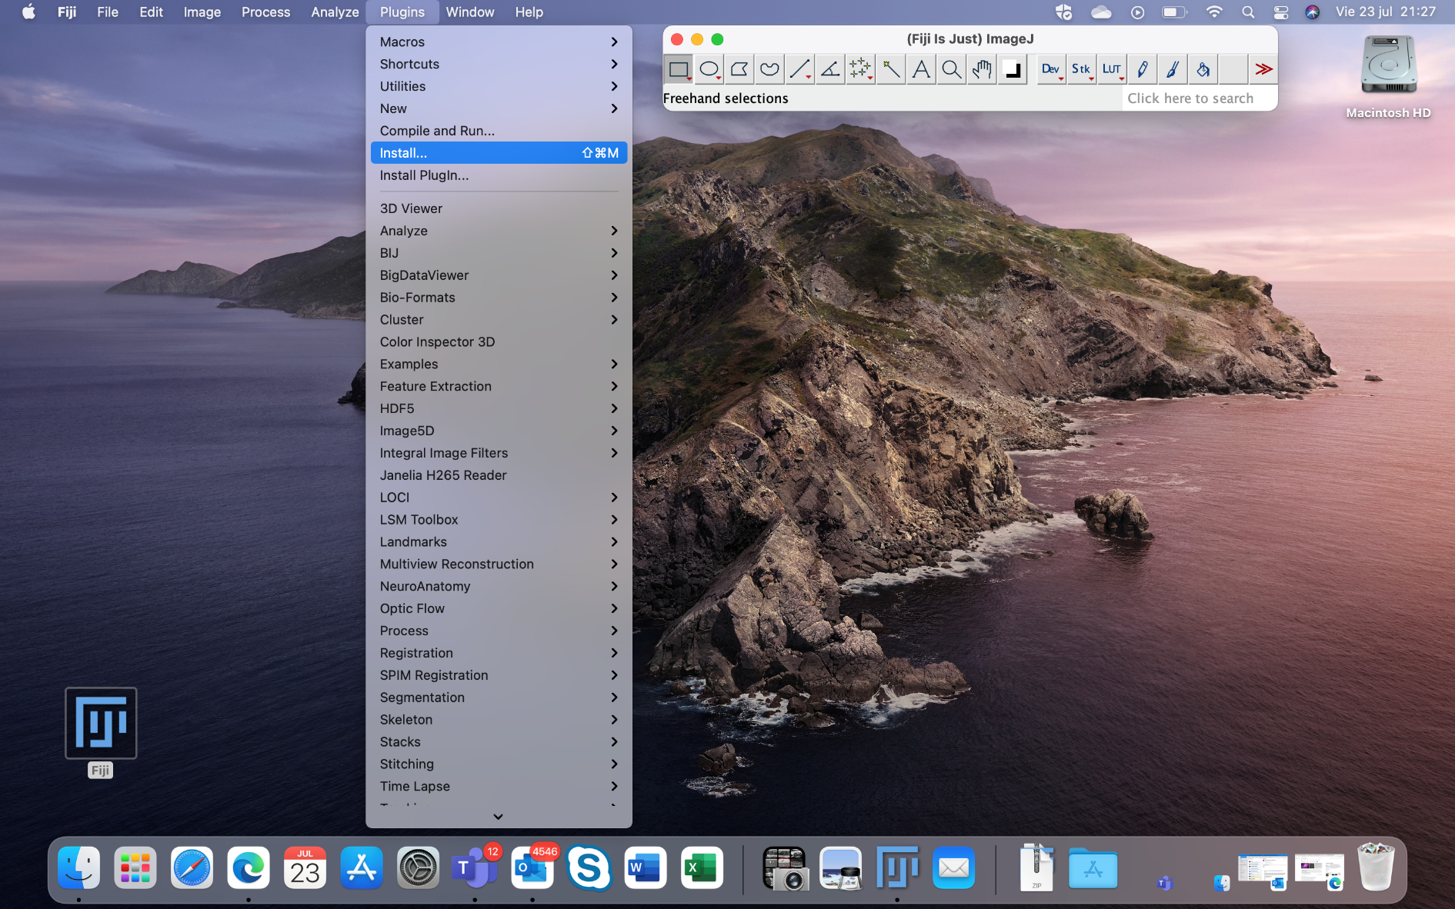

To update the plugin, repeat the steps above replacing the oldest version by the new one.

2. GENERAL CONSIDERATIONS ON THE OPERATION OF THE MACRO

• The macro is intuitive and easy to use. FIJI’s regular users may make it work without any further reading. We strongly recommend itchy users to try this video tutorial:.

• Once executed, the macro will guide the user through consecutive steps via popup windows filled with text instructions and action boutons. Occasionally, the user will be asked to interact with images to perform a task (checking automatically detected crossovers, for example). Most FIJI’s commands can be accessed meanwhile, bear in mind that inappropriate use of this feature can cause undesired results (e.g., closing the image under analysis will cause the macro to fail in a following step).

• The macro will consecutively process all images in a folder. Images to analyze must be of the same kind (*i.e*. have the same file extension). They should also have the same channels’ number and distribution, otherwise the macro could deliver unexpected results. Non-image files, subfolders and images with different extensions on the folder under analysis will not have any effect.

• The macro works on multichannel images. Channels’ content determines the analysis that can be performed, as shown in table 1.

|  |  |  |
| --- | --- | --- |
| Minimum number of channels | Channel’s content | Analysis |
| 1 | SCs | SCs length |
| 2 | SCs, DAPI | SCs length |
| 2 | SCs, COs | SCs length, COs positions relative to a random SC end |
| 3 | SCs, COs, DAPI | SCs length, COs positions relative to the most DAPI intense SC end |

Table 1: minimum number of channels per image to perform each meiotic recombination analysis. Extra channels need not to be used, *i.e.,* SCs length only analysis can be performed on three channel images.

Three channel images allow for conducting all meiotic recombination analysis, two channel images allow for SCs and COs analysis, at least one channel is needed for the macro to work. A DAPI channel is used for aiding the user to locate nuclei and telomeric centromeres (in some species, i.e., mouse, the centromere is always at one chromosome end and is more intense for DAPI staining).

• Results will be automatically saved in a “Results” folder in the source images folder. This folder will be overwritten if Synaptonemal & CO analyzer is run twice on the same images folder, should this be the case, the macro would create a warning and give the user the chance to rename or relocate the “Results” folder prior to overwriting it.

• The macro can be interrupted anytime by selecting a window and pressing the "i" key on the keyboard.

• FIJI's magnifying glass and scrolling tool can be used to better edit and analyze images. Use the magnifying glass to zoom in (left click) and zoom out (right click) the image. Use the scrolling tool to move through an amplified image (the scrolling tool can be activated anytime by pressing the space bar on the keyboard). Follow this link for more info on FIJI’s tool bar: <https://imagej.nih.gov/ij/docs/tools.html>.

• It is not possible to revisit all previously executed steps. However, checkpoints are established on critical decisions and the opportunity is given to correct mistakes and modify automatic detection results (e.g., automatically detected SCs can be manually shortened, elongated or trimmed afterwards).

• The “Results” folder contains a subfolder per each analyzed image named after it. The following files are created (Fig.20):

* A .tif multichannel image of the analyzed nucleus (Fig.2, left).
* A text file containing a table with all measured distances on each SCs. This table contains each individual SC total length and the sum of all SCs lengths. In the event that COs have been analyzed, the number of COs per SC and nucleus are also computed, and the total SC length is split into partial lengths (length from the beginning of the SC to the first CO, lengths between intermediate COs and length between the last CO and the SC end)(Fig.2, right). This file can be imported into Excel or any other spreadsheet for analysis.
* Compressed .zip folders containing coordinates for the detected nucleus, COs, SCs and centromeres positions (or SCs starting points, if no DAPI channel has been selected). These folders allow for visualizing detected structures over the analyzed image. If willing to check results, simply open the analyzed image and drag and drop any of these files to FIJI’s main window to overlay the desired structures (Fig.2, left). This visualizing tool depends on a FIJI’s function named ROI Manager, click this link for further reading on how to use this tool: <https://imagej.nih.gov/ij/docs/menus/analyze.html#manager>.

Those files allow for checking results any time after the analysis is done.

***Figure 2. Left: .tif results image. Nucleus, COs, SCs and centromeres are overlayed. Right: Results table showing the number of COs per SC, SC’s total length, distance between the centromere and the first CO (Patial length-1), distance between the first and second COs (Partial length-2), etc. Partial lengths are only calculated if the user performs a CO analysis, otherwise only SCs length are computed.***

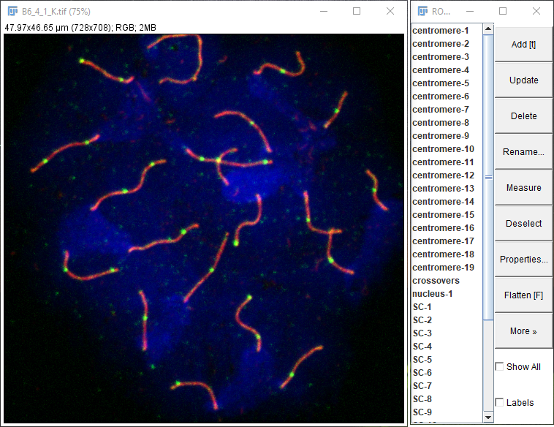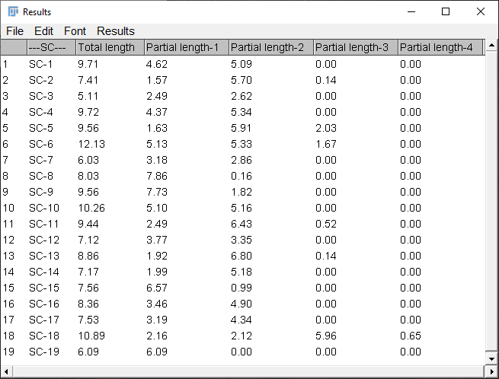

***Figure 2. Top left: .tif results image. Nucleus, COs, SCs and centromeres are overlayed. Top right: ROI manager allows to select each centromere, SC, nucleus and COs. Bottom: Results table showing the number of COs per SC and nuclei, each SC’s total length, nucleus SC total length and the distance between the centromere and the first CO (Patial length-1), the distance between the first and second COs (Partial length-2), etc. Partial lengths are only calculated if the user performs a CO analysis, otherwise only SCs length are computed.***

3. WORKING WITH SYNAPTONEMAL & CO ANALYZER: ANALYSIS OF SCs and COs.

**1. Run the macro.**

Click on Synaptonemal & CO analyzer on the Plugins menu to execute the macro (Fig.1, bottom) then follow the instructions on the following windows. Upon starting, the macro will automatically close all FIJI open windows (Fig.3) nonetheless, the user has the chance to save any previous unsaved data.

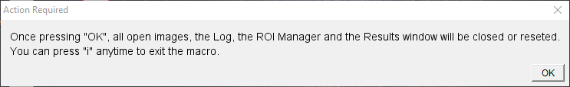

***Figure 3: executing Synaptonemal & CO analyzer re-initializes FIJI, but the user is warned to save valuable data before.***

**2. Select the images’ folder.**

Choose an image in the folder containing the images to be analyzed (Fig.4). Make sure that this folder meets the requirements described on the “General Considerations” section.

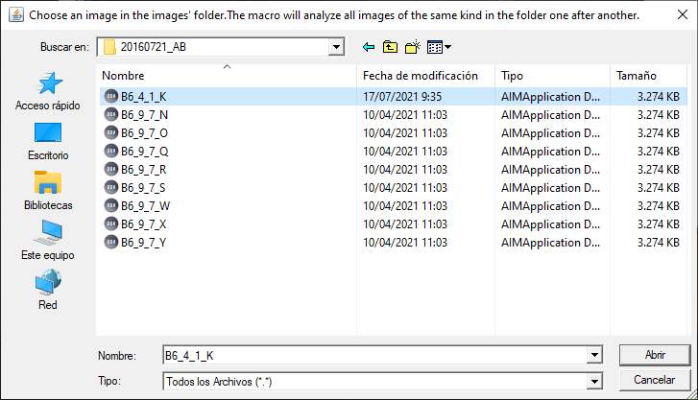

***Figure4: after choosing the selected image, all images in the folder with the same file extension will be consecutively processed.***

**3. Select an analysis.**

Choose whether to compute SCs’ lengths and numbers only or SCs’ length and numbers plus COs numbers and positions (Fig.5). If the first option is chosen, the macro will continue until the end of step 7, otherwise the macro will execute all following steps.

***Figure 5: the user can choose*** ***whether to compute SCs’ lengths and numbers only or also COs’ numbers and positions. If a DAPI image is chosen later on, COs’ positions will be given relative to the most intense DAPI end (i.e. the centromere in mice), otherwise, they will be computed from a random SC end.***

Enter the contents of each image channel. For instance, enter 2 on the field “SCs are in image:” if the second channel of a multichannel image is containing a SCs staining (Fig.6, top). Channels contents are shown in a separate image (Fig.6, bottom). This menu is versatile, it won’t ask for COs if “Compute only SCs” option is chosen in the previous menu (Fig.5) and it won’t pop up if a single channel image is being analyzed (under this situation, the only possible analysis is a SC length analysis, consequently the macro will assume that the single channel image is containing SCs).

If the field “Nuclei are on image: “ is set to 0, COs positions will be given relative to one SC end at random. Otherwise, the selected channel will be used to compute the SC end with the most intense DAPI staining (*i.e*., centromeres in mice).

Meaningless options will deliver an explanatory error and the menu will pop up again so the user can introduce correct values.

***Figure 6: Selecting the SCs, COs and nuclei channel (if any). Top: When analyzing SCs and COs, the number corresponding to the SCs, COs and nuclei image is asked to be selected. Bottom: A preview of the different channels of the image to be analyzed is shown to facilitate the operator's task.***

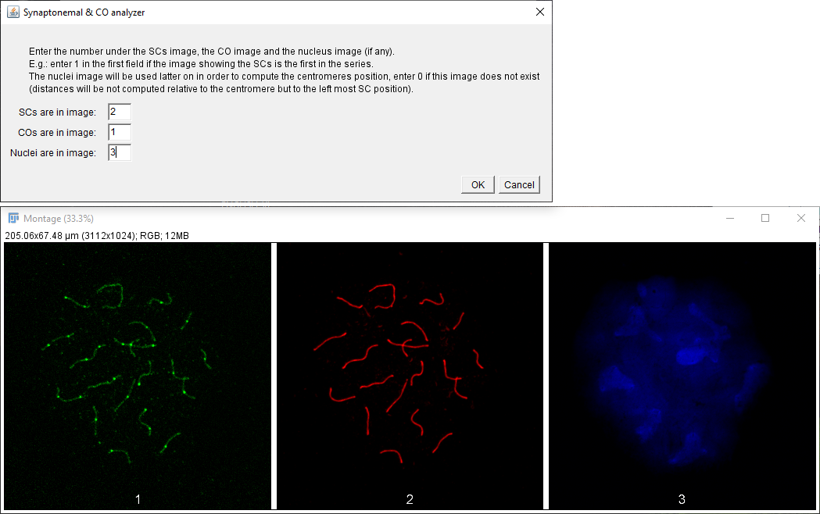

**4. Nucleus selection.**

The macro automatically opens the first image on the images folder. Create a selection surrounding the area containing the SCs’ to analyze using the more suitable channel (Fig.7). Click the “Add (t)” button on the ROI Manager and click “OK”.

By default, the polygon selection tool is selected, however, the user can use any selection tool on FIJI. If no closed selection is done a following menu will offer the opportunity to either create a new one or analyzing all SCs in the image.

Follow this link for more info on how to use FIJI’s selection tool: <https://imagej.nih.gov/ij/docs/tools.html> .

Tip: leave the XY chromosome SC out of the selection if possible, so you don’t have to erase it afterwards.

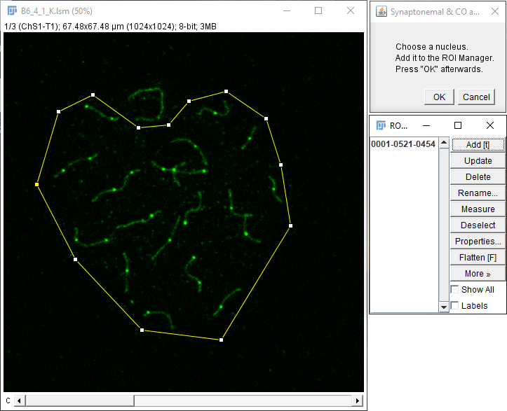An image containing different nucleus or groups of chromosomes needs to be analyzed twice, selecting each different group on subsequent analysis.

***Figure 7: only SCs inside the selection will be analyzed. Note that the sex chromosome is out of the selection to avoid deleting it afterwards. Use the bar in the lower part of the image to visualize the channel best suited for this task. The selected area has already been added to the ROI Manager (right bottom).***

**5. Intensity-based SCs selection.**

A black and white image containing the SCs automatically opens together with the Threshold tool as shown in *Fig. 8, top*. Use the scroll bar to highlight the SCs trying to get rid of as much background as possible while keeping SCs’s signal (*Fig. 8, Bottom*). Follow this link for more info regarding the Threshold tool: <https://imagej.nih.gov/ij/docs/guide/146-28.html> .

***Figure 8: SCs are selected by means of its intensity using the Threshold tool. Top: Image prior to the Threshold adjustment. Bottom: Image after the Threshold adjustment using the panel showed on the right side.***

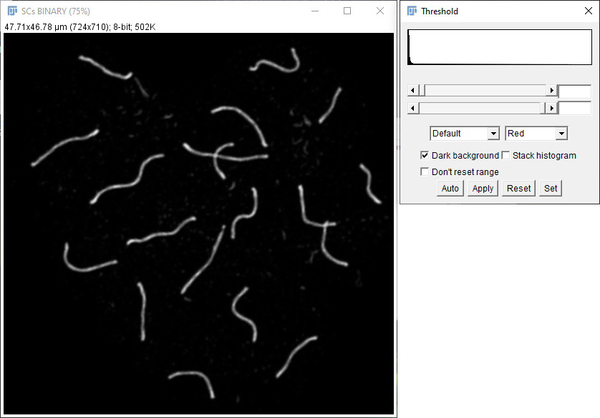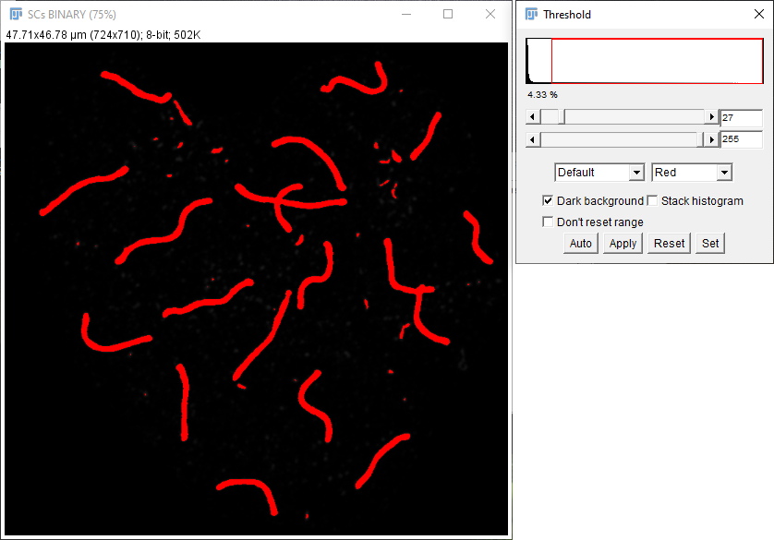

**6. Smooth manual SCs selection.**

Once pressing OK, two images containing SCs pop up. One of them (“SCs BINARY”) shows a single pixel width representation of the selected SCs in black and white (Fig. 9, bottom left). The other image (“SCs 8-BIT”) shows the original image for comparison purposes (Fig. 9, bottom right).

Press on “Synchronize All” and process the SCs on the black and white image until it represents a pixel width line of the SCs on the color image (Fig.9, top left).

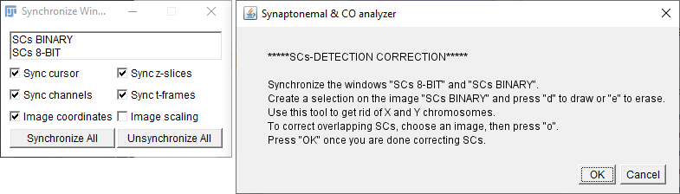

***Figure 9: intensity-selected SCs can be corrected before analysis by using a set of tools. The bottom left image shows a single pixel representation of selected SCs in white, the bottom right image shows selected SCs in yellow over the original image. Both images must be synchronized (top left) so zoom and selections drawn in any of them are shown in both images at the same time.***

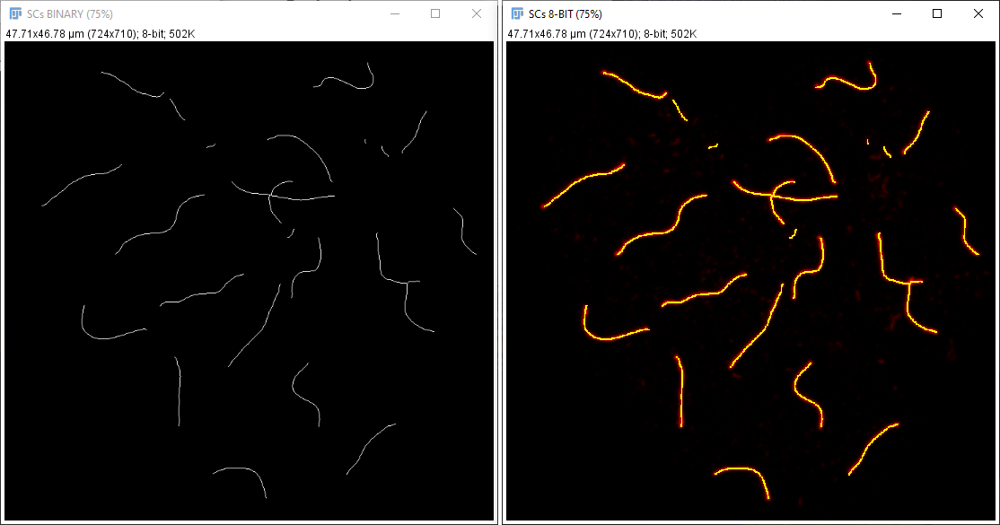

Editing instruction are shown, briefly:

* Erasing: choose a selection tool on FIJI, create a selection over the region to erase, then press “e” on the keyboard (Fig.10). Use this tool to erase the XY chromosome SC if necessary. The “Rectangle” selection tool is recommended for fine SCs pruning while the “Polygon” selection tool works better for entire SCs deletion.

***Figure 10: Manual removal of a signal erroneously detected by the macro using the "rectangle" tool. Top: erroneously detected SCs, notice rectangle tool selection prior to erasing. Bottom: corrected SCs.***

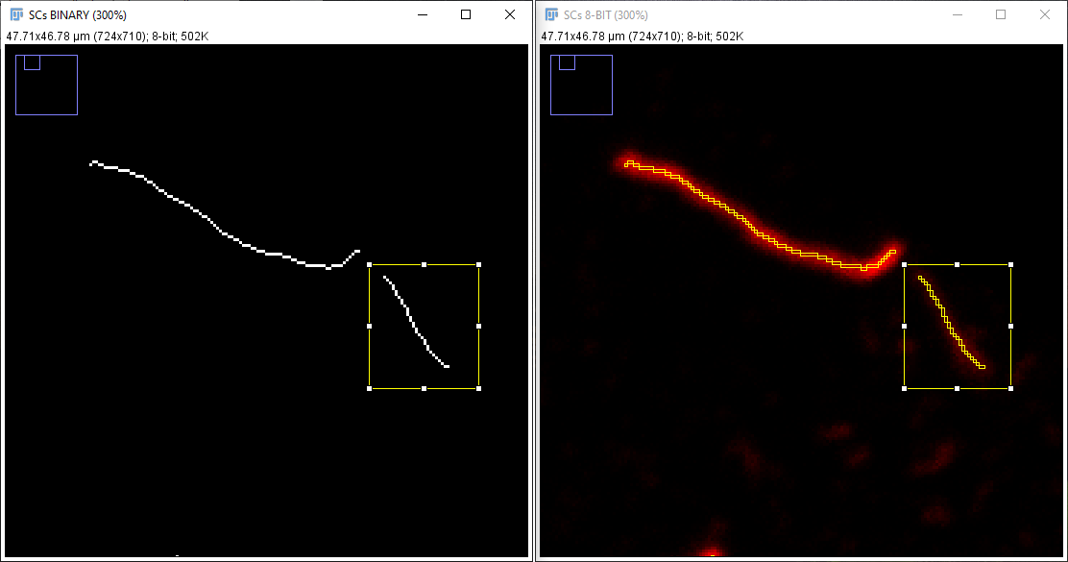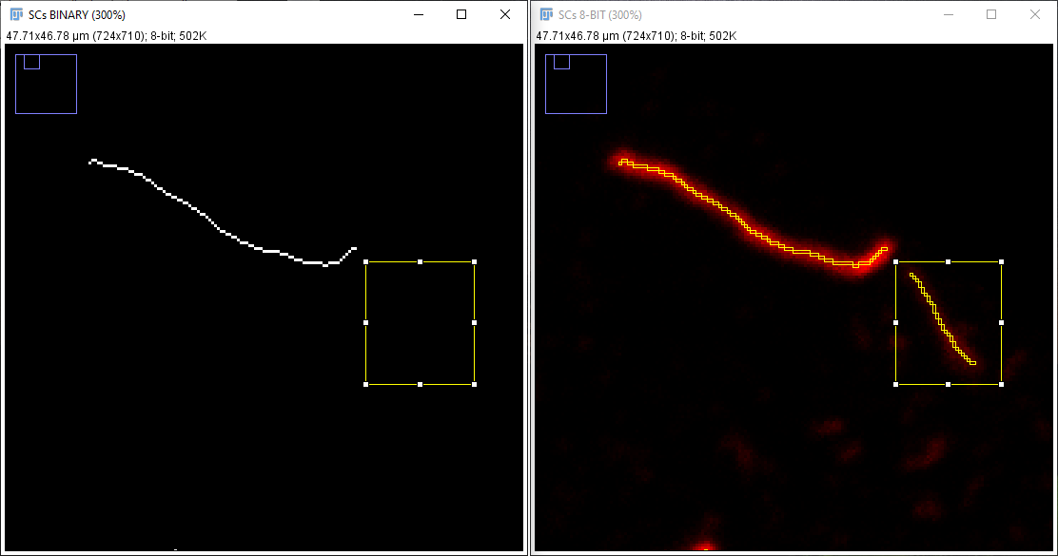

* Drawing: choose a selection tool on FIJI, create a selection over the region to draw (Fig.11, middle). then press “d” on the keyboard (Fig.11, bottom). The “Freehand”, “Straight”- and “Segmented-line” tools are recommended (follow this link for more info on how to use them: <https://imagej.nih.gov/ij/docs/tools.html> ).

***Figure 11: Manual drawing of a signal badly detected by the macro. Top: badly detected signal on a SC. Middle: user-made segmented-line selection prior to drawing (notice it follows real SC skeleton on the right image) . Bottom: corrected SC signal.***

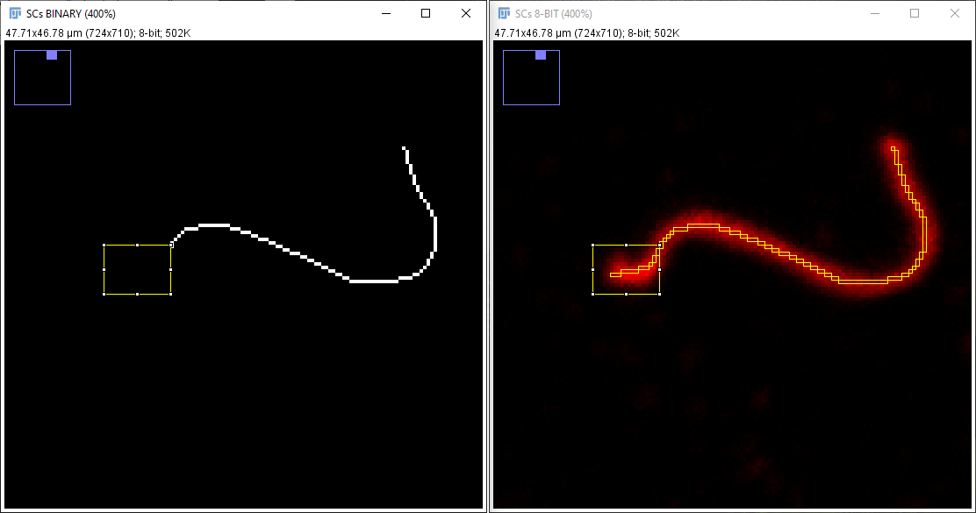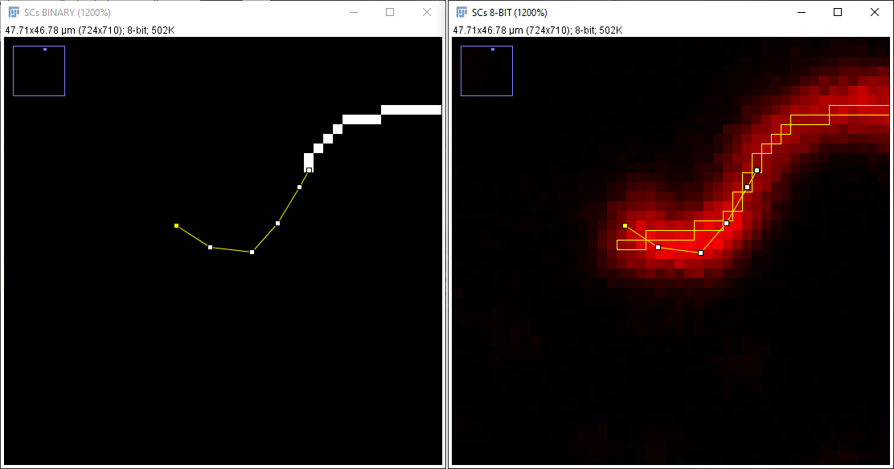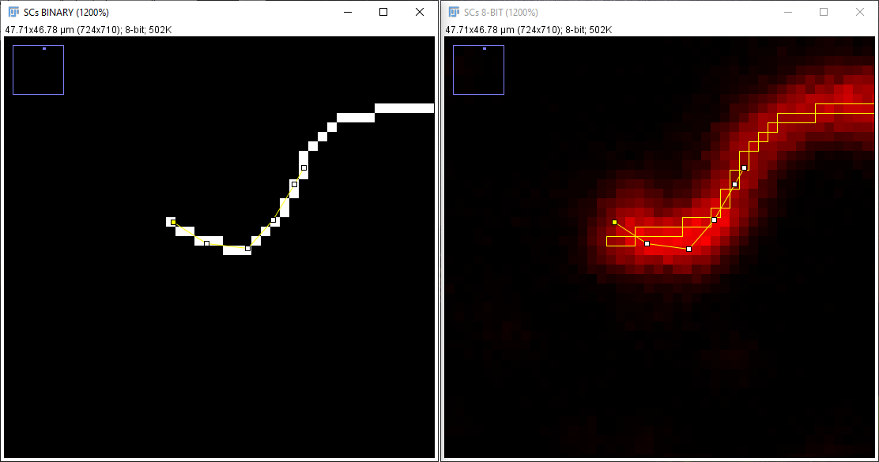

* Correcting overlapping SCs: choose an image, press “o” on the keyboard and follow instructions. 1- Enter the number of overlapping SCs and create a selection containing the overlapping chromosomes (Rectangle or Polygon selection tools recommended) (Fig. 12, top). When doing so, make sure that no other SCs but the ones overlapping fall into the selection. 2- A pop-up window will instruct the user to draw one of the overlapping SCs, do it by using the erasing and drawing tools above (Fig. 12, bottom). Press “OK”, then repeat the same procedure for the remaining overlapping SCs.

Please notice that two windows with instructions and an “OK” button remain open in this step, make sure to press the “OK” button in the last appearing window immediately after following the directed instruction, the macro will end up and deliver an error message otherwise.

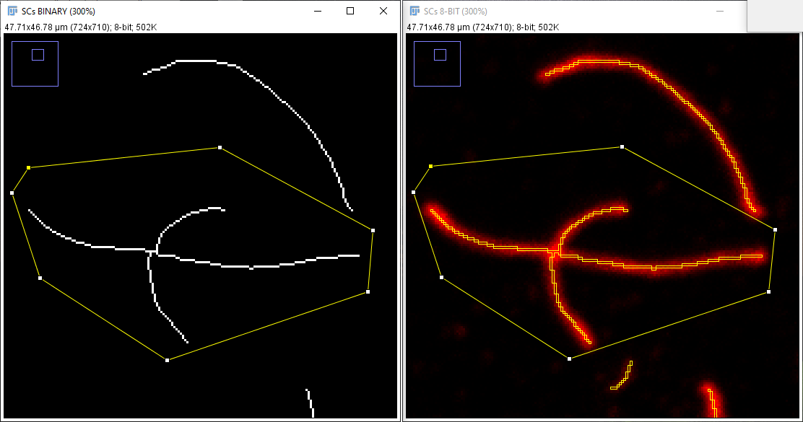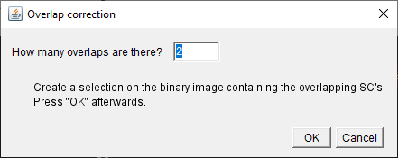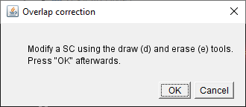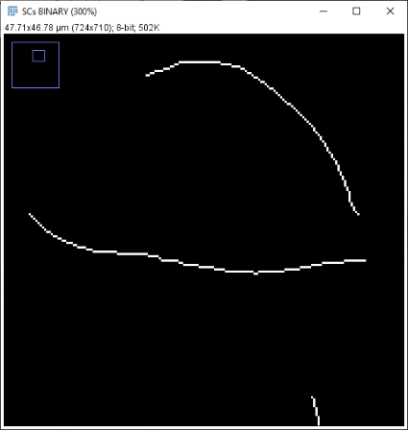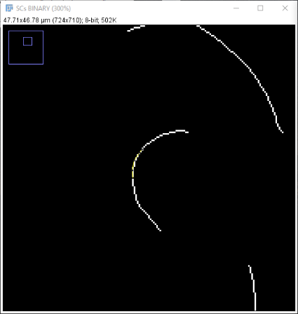

***Figure 12: Correcting overlapping SCs. Top: left, the number of overlapping SCs (two) as introduced in the text field. Right: the polygon selection tool has been used to create a selection containing the overlapping SCs only. Bottom: right, a single SC as a result of erasing the overlapping one with the erase tool. Left, after pressing “OK” overlapping SCs are drawn again so the user can isolate the remaining one.***

Once all needed modifications have been made, press the "Ok" button shown in Fig.9 top-right.

**7. Automatic SCs detection**.

The macro automatically checks the SCs for branching points. If any were detected the user is redirected to step 6 to get rid of them by using the aforementioned editing tools. SCs are numbered to facilitate its detection (Fig, 12).

***Figure 13: Branching points are automatically detected. The user is directed to them for editing.***

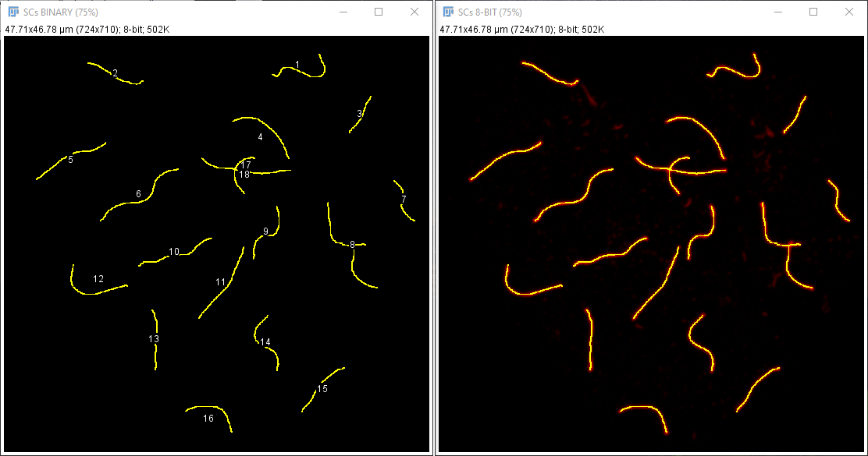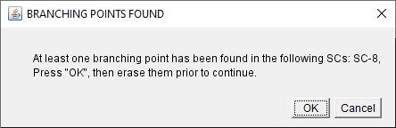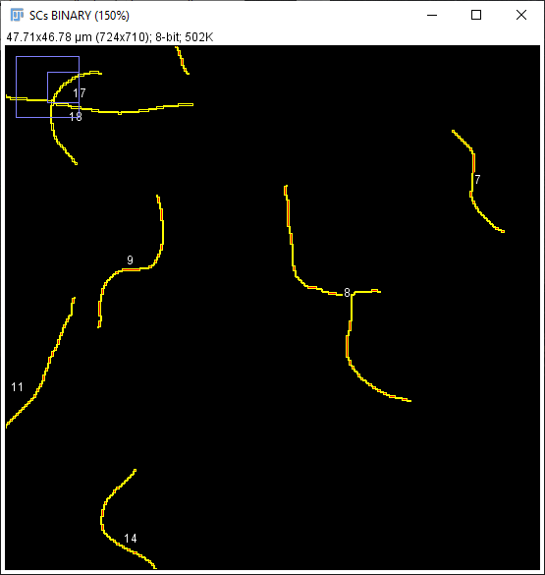

The macro will finish here by automatically analyzing selected SCs in case “Compute only SCs” was selected on step 3, otherwise step 8 will be executed.

**8. Automatic COs detection.**

Choose whether trying to locate COs automatically or locate them manually (*Fig. 14)*

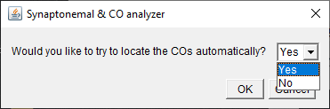

***Figure 14: the user can choose*** ***whether to locate COs automatically or manually.***

To locate COs automatically, create some selections over the SCs background, it should contain fragments of SCs that lack COs (*Fig.15*). Press the shift key on the keyboard to do different selections. The Polygon selection tool is recommended.

Tip: the automatic detection routine works better if SCs’ fragments with a fairly bright background are selected.

***Figure 15: Automatic COs selection. Choose background signal by using the Polygon selection tool. Do not select COs nor parts of the image without any background at all.***

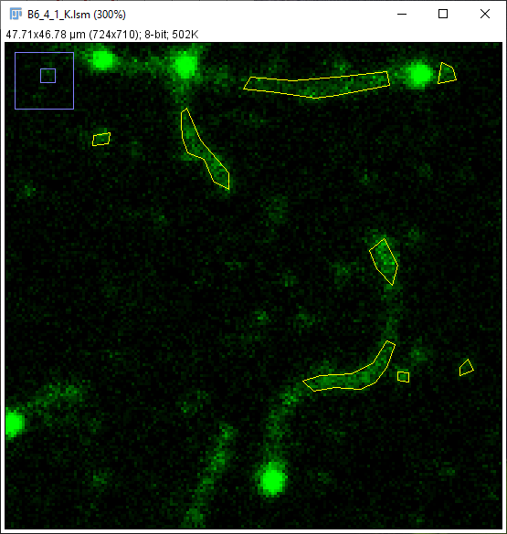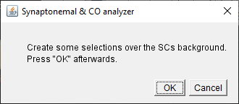

Press OK, then check the automatically selected COs (Fig.17) and choose whether to continue correcting minor errors manually or locating COs manually (Fig.16).

***Figure 16: Check automatically detected COS, if happy with results, minor errors can be corrected manually, otherwise all COs can be selected manually.***

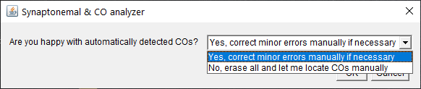

**9. Manual COs selection correction.**

The macro is similar whether the user chooses to perform a manual COs detection at step 8 (Fig.14), if it chooses to locate COs manually after a failed automated COs detection or whether willing to correct minor errors after a successful automatic COs detection (Fig.16). In all cases the original SC image is shown (Fig. 17, with or without previously detected SCs) and the user is given the opportunity to:

1. Left click on any location to add a CO.
2. Hold down the “Alt key” and left click on a CO to delete it.
3. Right click over a CO and drag and drop to change its location.

Make sure that the Multipoint selection tool is selected during this process (although automatically selected, it is sometimes left unselected after zooming in/out the image, which we strongly recommend).

***Figure 17: Automatically detected COs (red circles on the original COs image) can be added or erased manually according the given instructions. If no automatic analysis is done, all SCs must be added manually.***

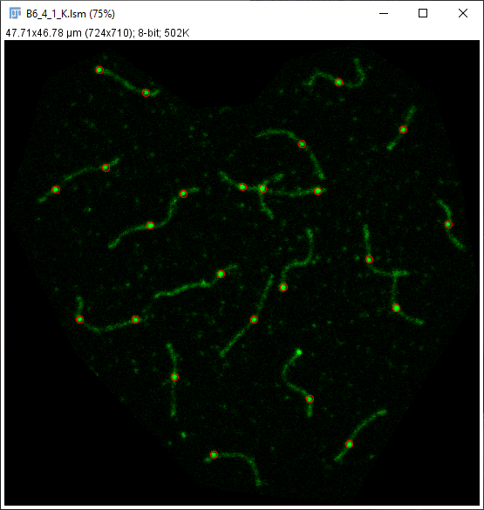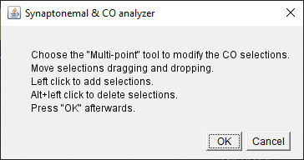

**10. Automatic COs examination.**

The macro automatically assigns each CO to the closest SC, if failing to do so, the troublesome CO is indicated and the user is instructed to move it to the closest SC.

***Figure 18: If any automatically detected CO cannot be assigned to a SC (red circle over the SC image), the macro will indicate the user to move it to the closest SC following the given instructions.***

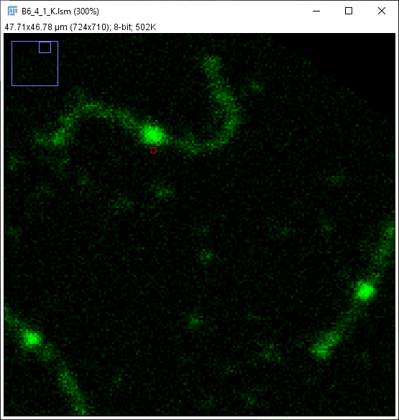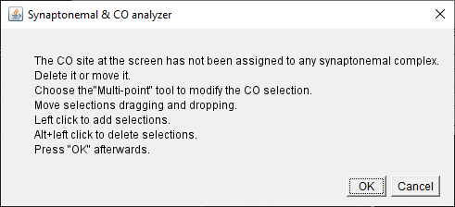

**11. Finishing the analysis.**

The macro automatically detects the centromere on every SC and analyzes the length of every inter CO distance starting from this point. Results are automatically saved as told in the General Consideration section.

Steps 4 to 11 are repeated for every image in the images folder. Once all the images in the folder have been analyzed, the macro will display a completion message.

4. SYNAPTONEMAL & CO ANALYZER: RESULTS.

Once the analysis is done, a subfolder named “Results” is created inside the folder that contained the original images. Inside the results folder, a subfolder with the name of every analyzed image is created. This contains four files if a SCs analysis was done (Fig.20, top), or six files in case an SCs and COs analysis was executed (Fig.20, bottom), as described on the “general considerations on the operation of the macro” section.

***Figure 20: Files contained on each image results folder as a result of running a SCs analysis (top) or a SCs and COs analysis (bottom). If a SCs and COs analysis was performed and a nucleus channel was introduced, centromere coordinates are recorded in the centromeres_positions file, if no DAPI channel was selected, a starting_points file would contain the coordinates of each SC from which COs distances are computed.***

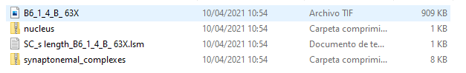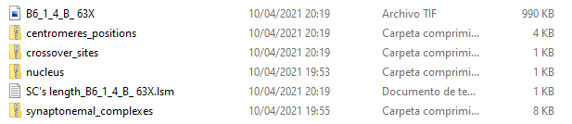

To view the results obtained, both the images and the measurement table, can be imported back into the program. These will be shown as seen in figure 21, and figure 2.

In order to open the image file and coodinates files. Simply drag and drop then into FIJI’s toolbar. In order to import the results, select File>Import>Results and select the path to the the results file in the pop up window. Go to Analyze>Set Measurements… and set “Decimal places (0-9)” to the desired results precission value.

***Figure 21: SCs measurement results displayed in FIJI. Left: RGB image, showing the SC selected in the ROI Manager tool (right) and the table containing SC lengths (center). Zip files containing centromeres, COs and SCs can be opened in the ROI Manager and selected for visualization.***

